**ENVIRONMENT SETUP FOR AWS CLOUD9:**

* **STEP-01:** Open AWS click on Services and go to cloud9. Click on create environment and give name to the environment, next step and create environment.

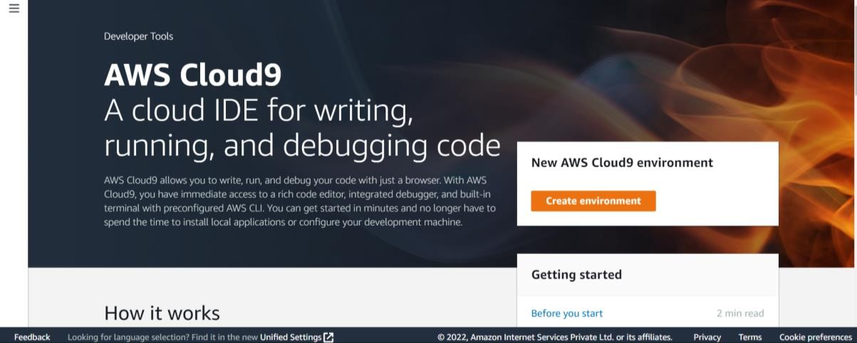

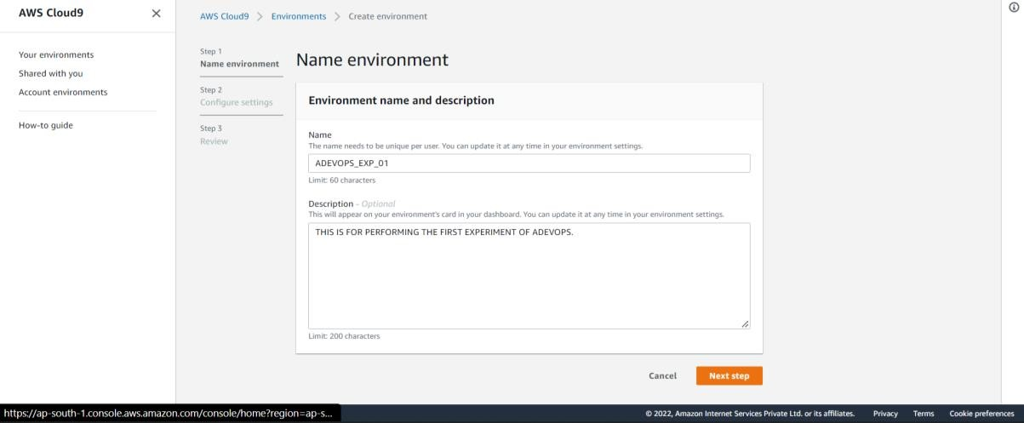

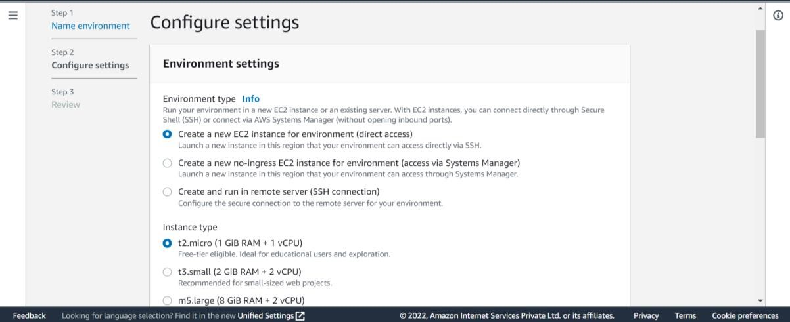

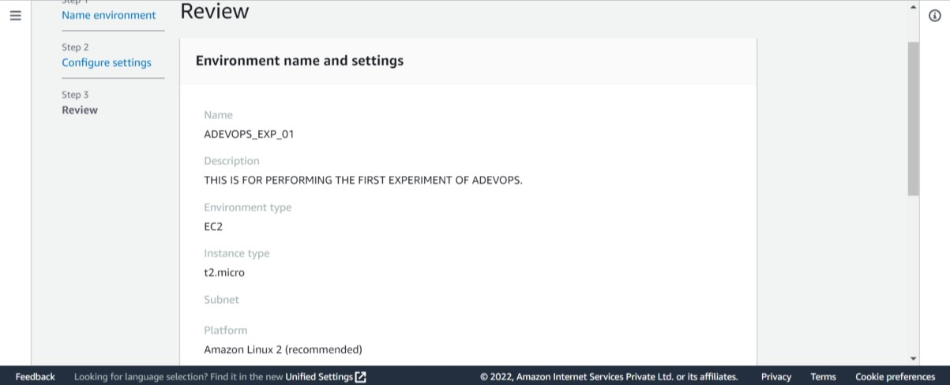

* **STEP-02:** Your AWS cloud9 environment will be displayed. (All integration will take place here.)

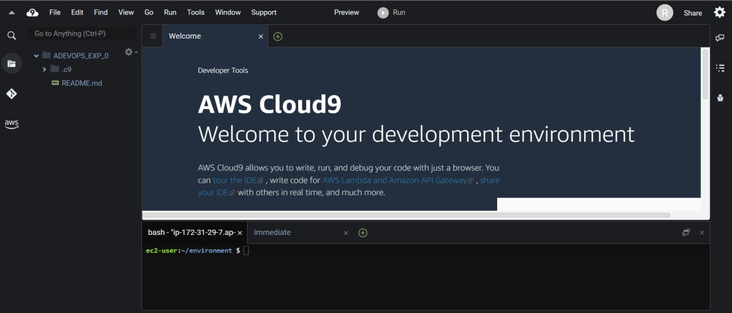

* + **STEP-03:** Now We can write code

